**ReconInsight**

**Shapefiles tutorial**

**August 2017**

**Shapefiles**

**You can find shapefiles from a variety of different websites. The best website to download shapefiles for US specific regions is the census.gov website found below.**

1. Follow this link <https://www.census.gov/geo/maps-data/data/tiger.html> to a page that looks like the image below.

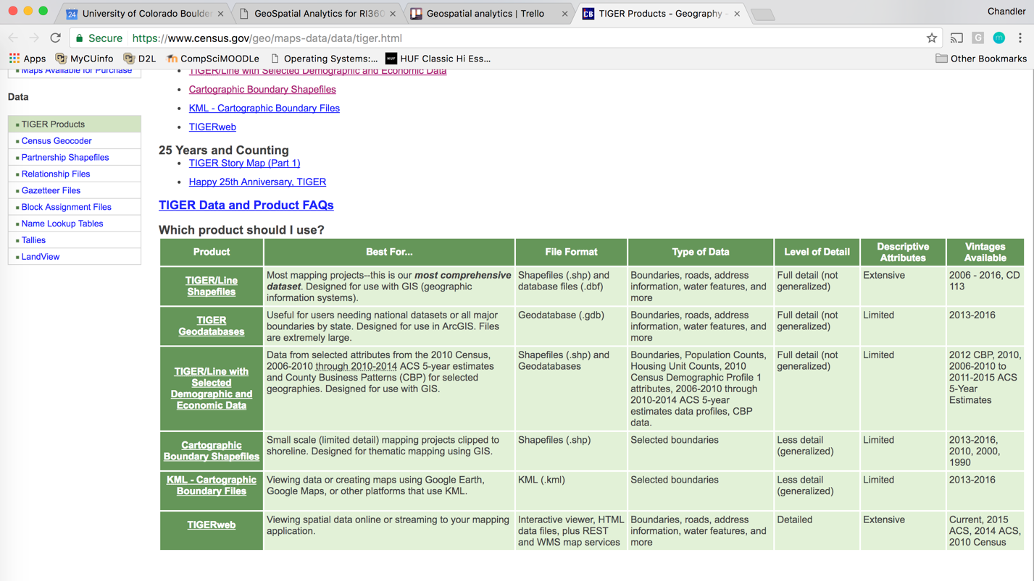

1. 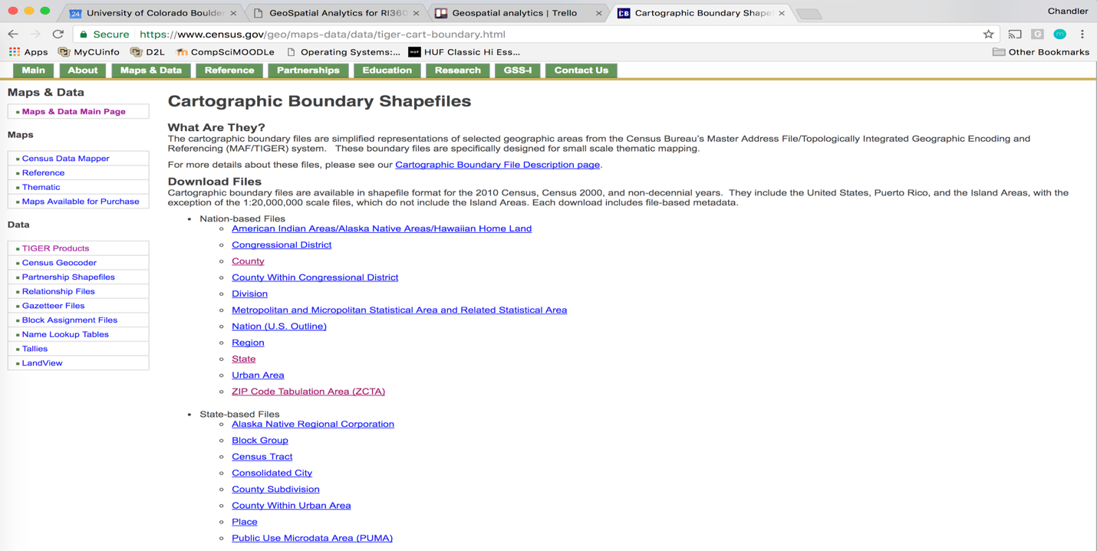Click on Cartographic Boundary Shapefiles
2. You are now presented with a large list of Nation and State based files to choose from.
3. Once you click on one Recommend to download 5m.zip

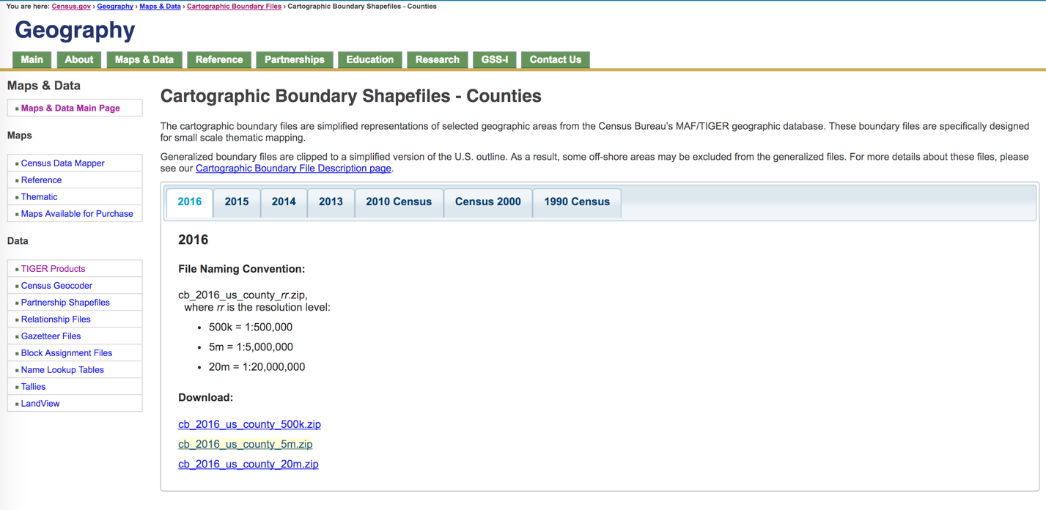

1. Open Terminal
2. Shp2geo <shapefile> -o <shapefile.geoJson>

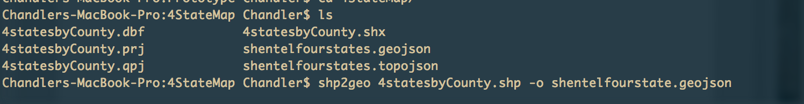

1. Geo2topo <shapefile.geojson> -o <shapefile.topojson>

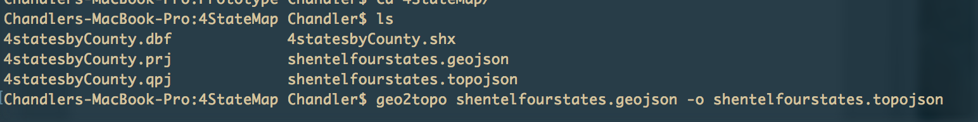

**QGIS Tutorial**

**QGIS is useful for selecting certain areas once you have a shapefile downloaded. For example, if you have a shapefile for the United States but you only want to select 3 or 4 states you would use QGIS to make a new shapefile containing only the selected states. This demonstration is using a map of the United States with counties. We are going to carve out California and turn the map into just California and counties inside.**

1. Once you complete steps 1 – 4 from above. Open Finder if mac or folder that contains your Zip file.

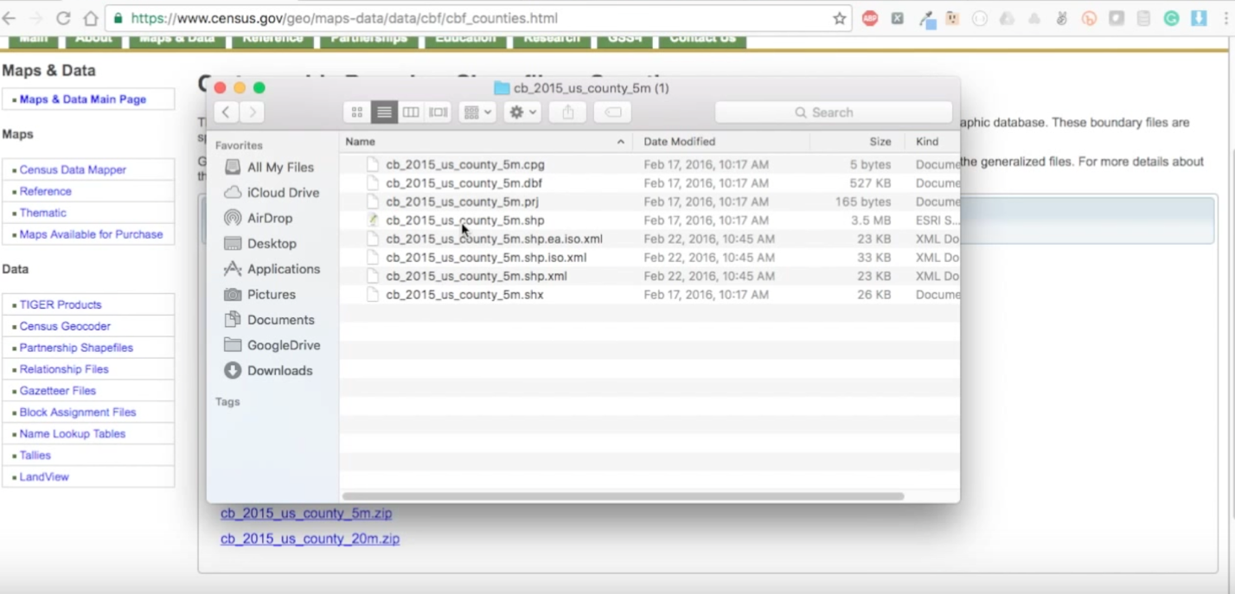

1. Double click on the .shp file that is included inside the Zip file
2. 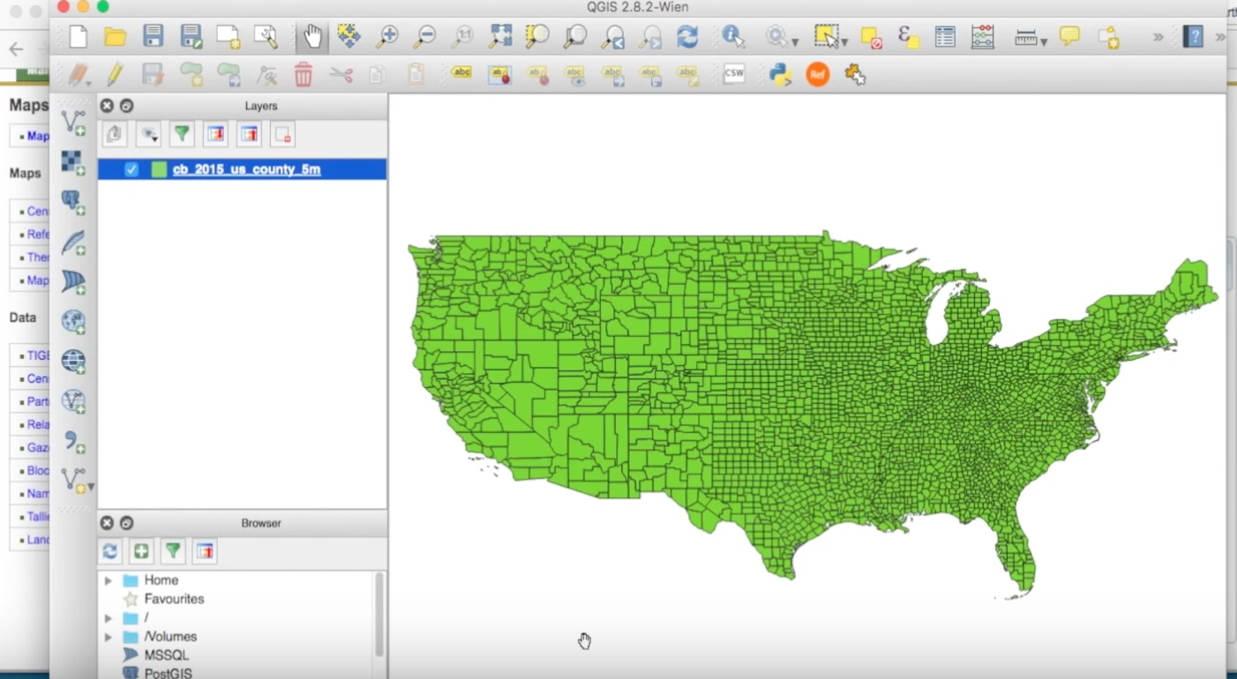QGIS should load the shapefile into the software and you should be presented with a map inside the GUI like this.
3. 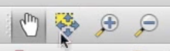Once the map loads you can use the zoom in(magnify glass with +) and zoom out(magnify glass with -) tool to help position your map. In addition, you can use choose the hand icon to help drag your map around.
4. Screen%20Shot%202017-08-11%20at%201.20.05%20PM.pngTo start carving out certain areas of the map, click on the expression tool that is located in the top right hand corner.
5. 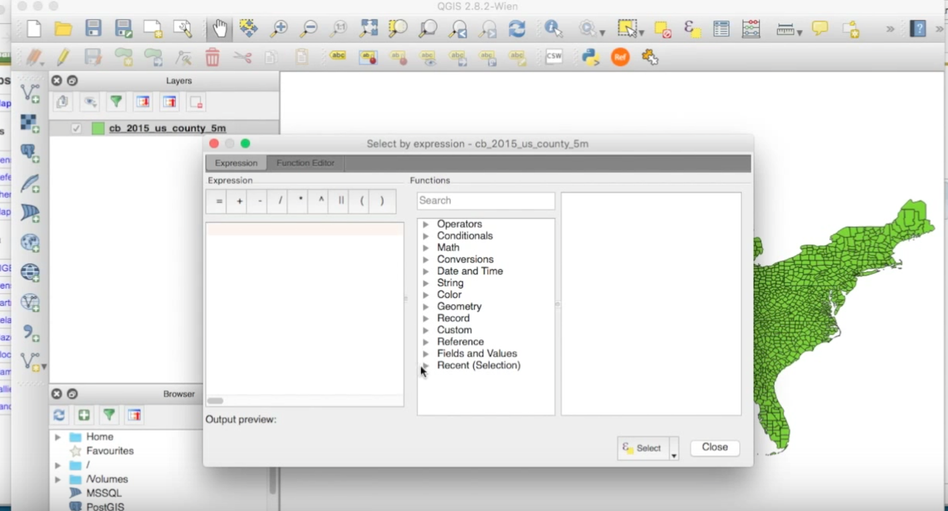Once you press this button you will be presented with a screen that looks like this.
6. 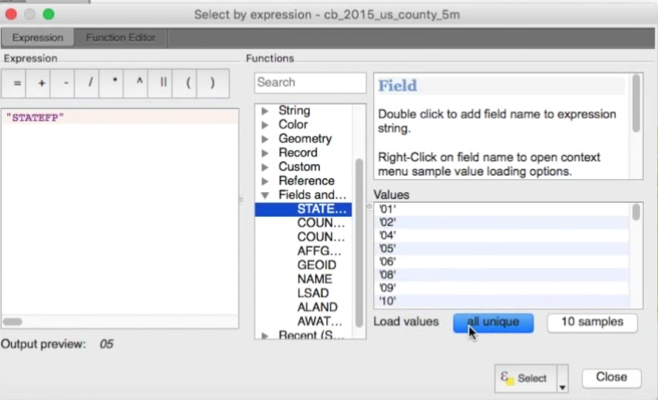Click on Fields and Values tab
7. You want to match the state you are trying to carve out with its FIPS code, so press STATEFP and click load the blue button at the bottom that says, “All unique”.
8. 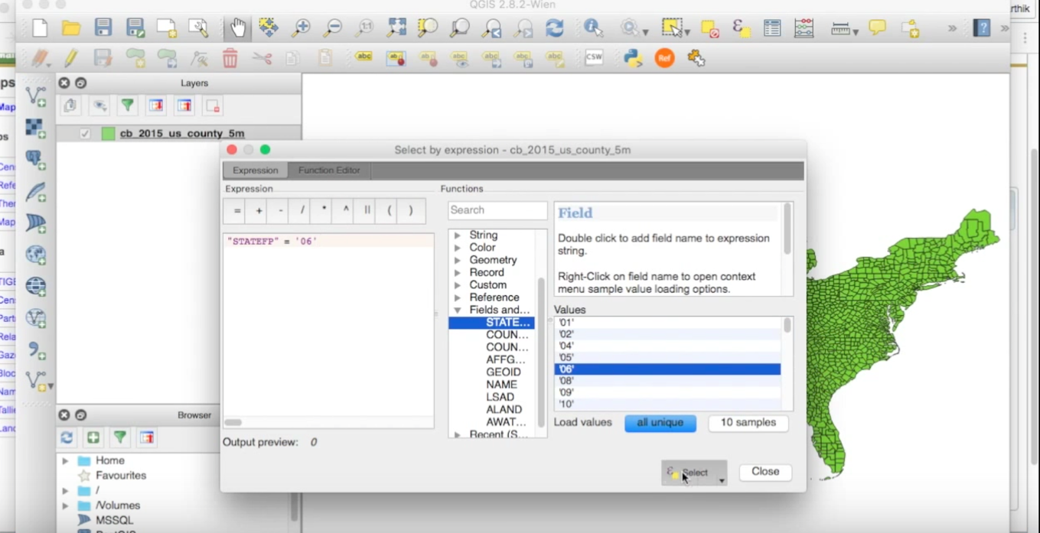First, click the equal sign in the top left corner… Then go to the loaded values and click on the FIPS code that represents your state. You can find a states FIPS code at this URL: http://www.columbia.edu/~sue/state-fips.html
9. Once the left window has a fields and values mark paired with an ID – press select and close.

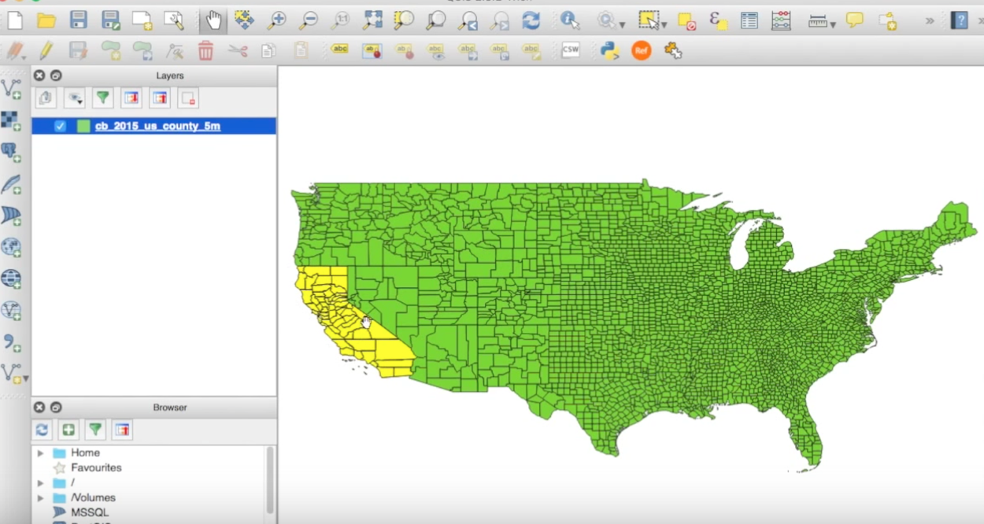

1. 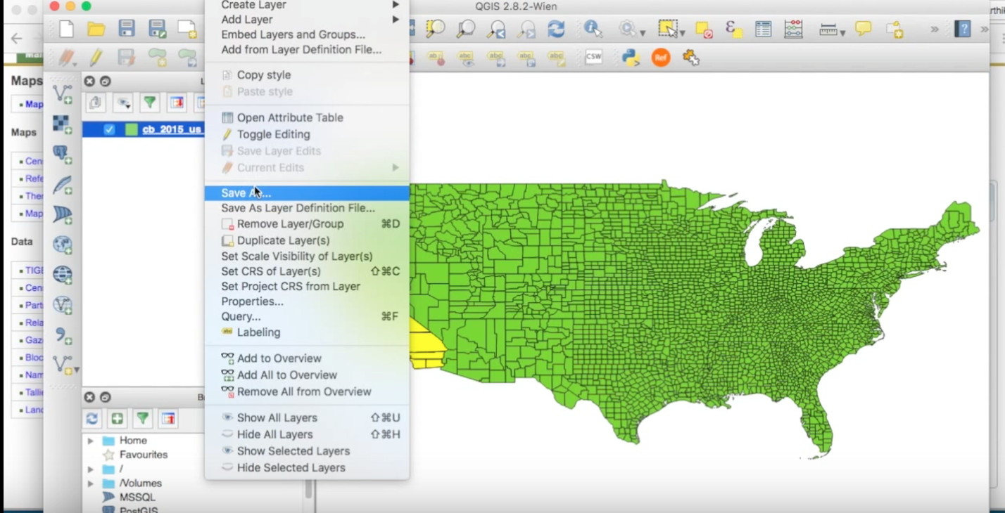Now that an area of the map is selected go to Layer > Save As…
2. 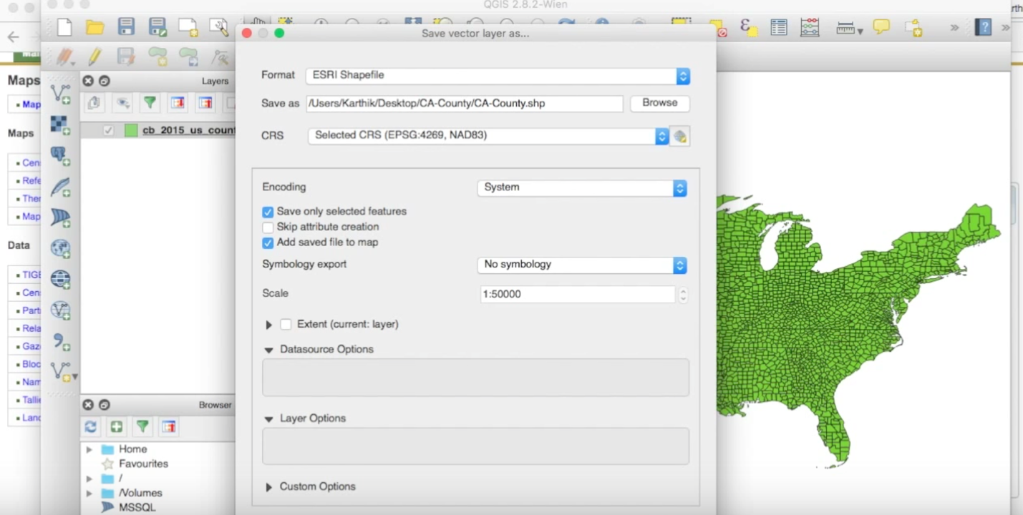Once you have the file path defined for where you want to save the new shape file. Check the “Save only the selected features”. This button is very important because we just selected a feature(california) and we want to make sure it gets carved out.
3. Once both boxes are checked press Okay at the bottom right hand corner.
4. You will be presented with the newly created shape file.
5. In order to turn that shapefile into a TopoJSON or GeoJSON object follow steps 5 – 7 in the Shapefiles tutorial.